How to apply for a volunteer role with the South Kitsap Soccer Club:

IMPORTANT: BEFORE you register via the club’s registration portal, you must complete your required training components and background check. Please follow this guide to minimize problems during registration.

Step One: Complete the training requirements as outlined in the “WYS Affinity Registration Guide”. You can find the guide HERE.

Important Notes:
- If you have ever volunteered with the club, you will already have an account.
- If you are unsure if you have an account, try to recover your username using the email address(s) that you may have used.
- If you are absolutely sure you have not previously created an account, you will need to create a new account in order to proceed.

Step 2: (ONLY AFTER COMPLETING STEP 1) Submit your volunteer request to the club.

Visit the following site:
https://clubs.bluesombrero.com/Default.aspx?tabid=854260

At the top of the page, click the “login” button.
You will be transferred to the Sports Connect login page. If you have an existing account, use your credentials to login. If you don’t remember those, utilize the forgot username or password options. If you don’t have an account, you will need to create one in order to proceed.

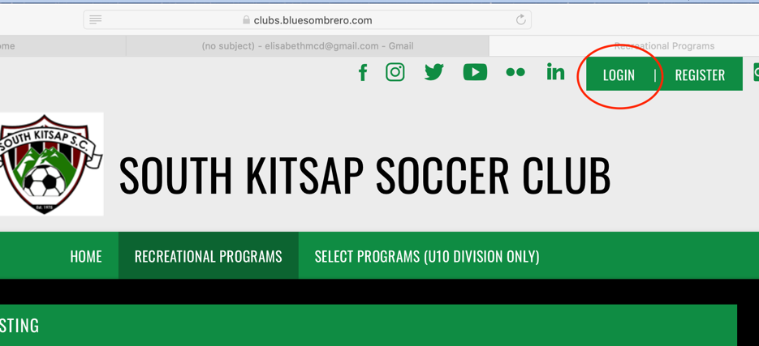

Upon logging into your account you will see the participants associated with your account. At the top of the page, click on the “Volunteer Opportunities” box (it may list “0” opportunities… but don’t worry).

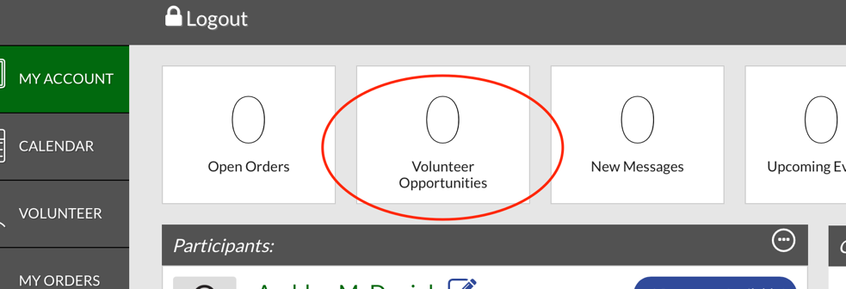

The next page will list any volunteer opportunities that you have applied for previously. If you are signing up for a new role, click the “Find Volunteer Opportunities” at the top right of the page.

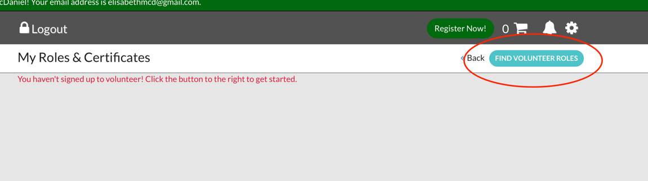

Next, you will see a page containing options for volunteering with the recreational or select program. Select the division you are intending to work with, and then click “View Available Positions”.

A list of opportunities for each division (age and gender) will be displayed. Scroll through the list and make sure that you click “sign up” for the position with the age and gender you are wanting to work with.
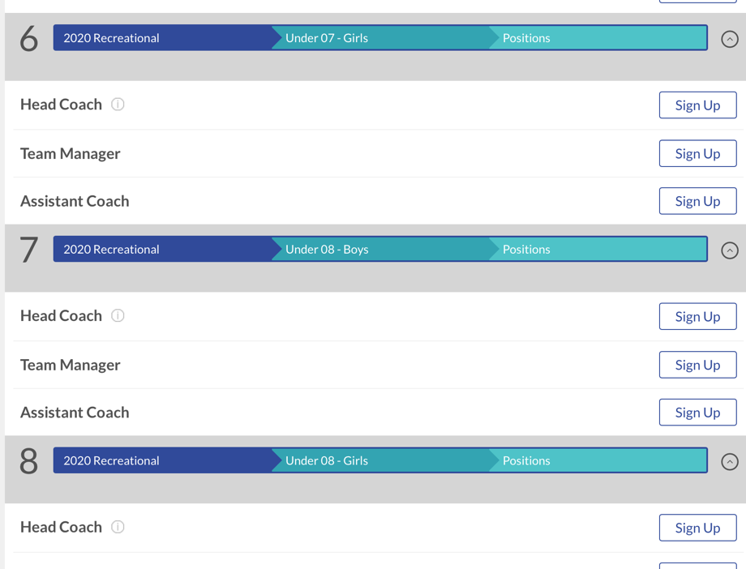
After highlighting the correct “sign up” link, scroll down to the bottom of the page and click “continue”.

The next page should ask for confirmation as to who you are signing up. If you are signing up yourself, highlight your name and click “Continue”.

Your next step is to complete your identification information and acknowledge the various legal notices.

At the end of the page, it will prompt you to upload copies of your concussion certificate, sudden cardiac arrest certificate, and Safesport certificate. The ONLY one that is required is the Safesport certificate (ignore the other ones). Upload a copy of your Safesport certificate (the same one you uploaded via the Washington Youth Soccer Affinity site).

Important Notes:
- The platform limits the size of your uploaded file to 5mb.
- The original certificate you downloaded from SafeSport is a PDF file that exceeds these limits.
- We suggest saving this file as a .jpg image which will reduce the file size.

